### Ex:No: 10

Date:

**Simple programming exercise using(REPEAT, WHILE )**

##### Program1

Write a function to build a string repeatedly until the value of the variable becomes s greater than 5. Then, we display the final string using a SELECT statement.

##### Program 2:

Write a function that uses REPEAT statement which would repeat the loopuntil income is greater than or equal to 4000, at which point the REPEAT loop would beterminated

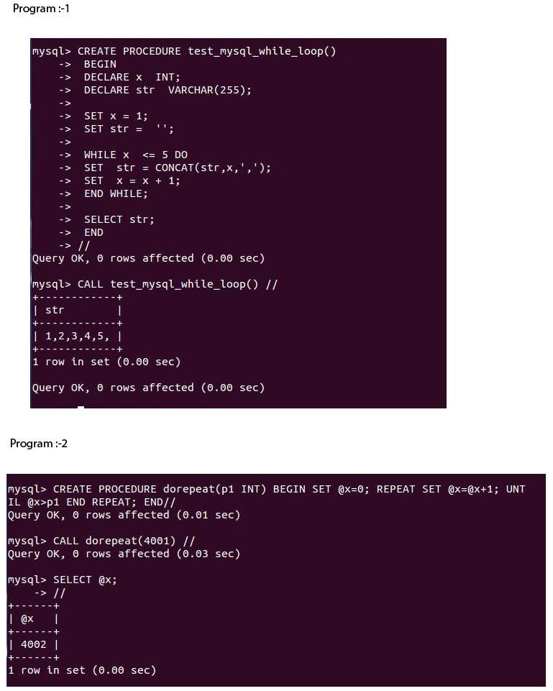

**RESULT:**Thus the Simple programming exercise using(REPEAT, WHILE ) exectuted successfully.